Home page (Quantlight and High harmonics)
Overall, the appearance is dynamic and attractive, featuring images and a cohesive theme.
- About the images that you included in updates from the lab, are they collected from the internet? Or AI-generated images?
The following details need to be included in the HOME tab,
Our exceptional experimental and technological capabilities allow us to innovate new frontiers in optics and photonics. Some of our expertise is listed below as follows:
Generating structured laser sources at Infrared, visible, UV, and deep UV wavelengths (description and images)
High-quality diffractive optics for high-power and lossless beam shaping (description and images)
Surface processing and structuring with vortex and vector light beams (description and images)
Laser drilling, cutting, and scribing with non-diffracting laser beams (description and images)
High-resolution imaging: problems and solutions (description and images)
XUV metrology and XUV imaging using structured light beams (description and images)
Lower-order and Higher-order harmonic generation driven by classical and quantum light.
(description and images)
The following details need to be included in the About tab,
Our mission:
At our lab, we advance laser and optics technology to promote innovation and design, enabling groundbreaking research in classical and quantum light, as well as high-harmonic generation from various media for advanced applications and highly demanded scientific studies.
Innovation:
At our Quantlight & High Harmonics Lab, we continuously incorporate the latest advancements and solutions in the development of laser sources and diffractive optics capable of functioning across multiple spectral ranges. Our efforts utilize versatile and efficient materials, optical technologies, and diffractive optics to achieve technological innovations.
Quality:
Our Quantlight & High Harmonics Lab is committed to delivering laser technology, diffractive optical elements, and optical solutions with utmost quality and precision, meeting the needs of scientific and engineering applications.
Performance:
Our diffractive optical elements and laser technology are engineered for high quality and superior performance in classical and quantum optics and photonics experiments and applications. We are excited about our diffractive optics, which have great potential for laser processing, optical communication, micromachining, microfabrication, and high-resolution imaging, supported by ongoing research.

Team
Leadership:
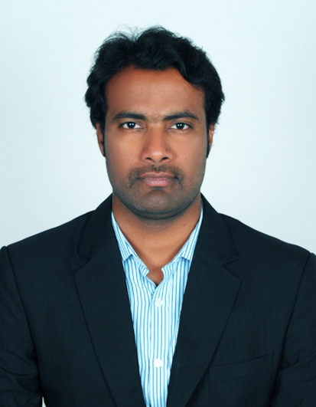
Dr. A. Naresh Kumar Reddy
Director, Head of Research and Development
Team Lead, developing structured laser technology for industrial and medical applications.
Research interests: Light-matter interactions, Beam shaping elements and technologies, High-harmonic generation & applications, Laser material processing (cutting, drilling, surface structuring), Additive manufacturing, Metalens, High-resolution imaging
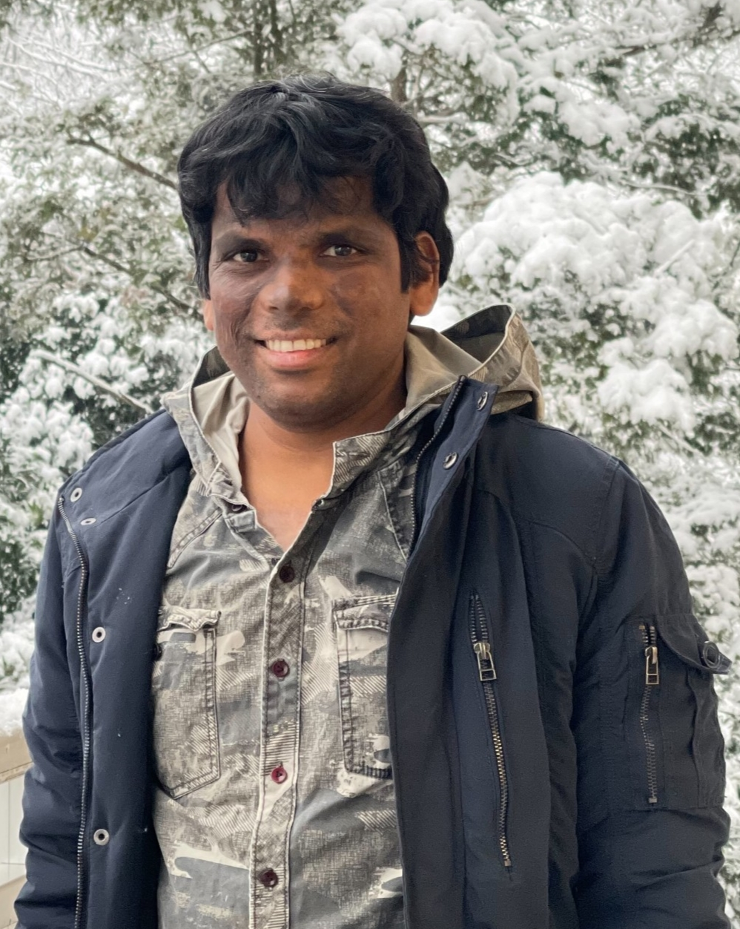
Work experience: 10 years
Dr. A. Srinivasa Rao
Head of Laser Engineering
Team Lead, developing high-power ultraviolet structured light sources.
Research interests: Light-Matter interactions, Laser Cavities, Nonlinear Optics,
Structured light, Optical Skyrmions, and Bio-photonics
Work experience: 10 years

International Research Advisors

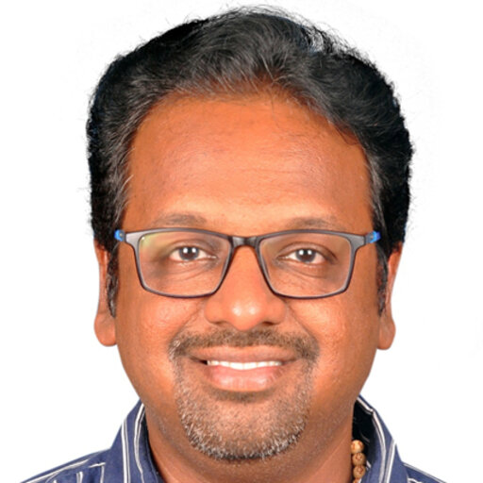

Prof. Vijayakumar Anand
ERA CIPHR Chair
Group leader, Computational imaging and processing with high-resolution
Institute of Physics, University of Tartu,
W. Ostwaldi, 50411 Tartu, Estonia.
Research interests: Incoherent imaging, Digital holography, Diffractive optics, and micro/nanofabrication

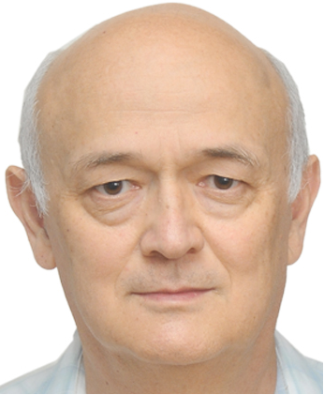

Prof. Rasheed A. Ganeev
Chief Researcher
Laboratory of Materials Science, Laser and Nanotechnology
Institute for Advanced Studies
New Uzbekistan University, Movarounnahr 1,
Tashkent 100007, Uzbekistan
Research interests: Nonlinear Optics, High-harmonic generation

